### Final Report

Project Title

Project 2

Purpose of Project

The project simulates a truck delivery system where a random seed is used to create a random number of trucks, warehouses, and shipments, and the trucks use a manifest to load and unload shipments at specific warehouse locations. Four different configuration files have been created which configure the simulation and each simulation is run 10 times with a different random seed. The file name of the configuration file to be used is entered when running the main method.

Simulation Results

The simulation logs each action of the truck to a separate csv file. The csv file logs the coordinates of the truck, the truck’s unique ID, and the action it is currently performing.

Sample tables from one truck for each of the simulation files are given below

| **Truck1** | **X** | **position** | **7363.0** |
| --- | --- | --- | --- |
| **Truck1** | Y | position | 1481.0 |
| **Truck1** |  | Status MOVING |  |

| **Truck13** | **X** | **position** | **1000444.0** |
| --- | --- | --- | --- |
| **Truck13** | Y | position | -74.0 |
| **Truck13** |  | Status MOVING |  |

| **Truck18** | **X** | **position** | **263.0** |
| --- | --- | --- | --- |
| **Truck18** | Y | position | 106.0 |
| **Truck18** |  | Status WAITING |  |

| **Truck7** | **X** | **position** | **4060.0** |
| --- | --- | --- | --- |
| **Truck7** | Y | position | 4618.0 |
| **Truck7** |  | Status MOVING |  |

Through the time that it takes for each configuration file to completely run,It can be determined which of the four configurations is most efficient.

Thus, as configuration file 1 has the least value for the timer variable, it can be concluded that it is the most efficient.

The Final Results determined can be seen below

| Configuration File | Timer |
| --- | --- |
| config_1 | 10 |
| config_2 | 35 |
| config_3 | 46 |
| config_4 | 102 |

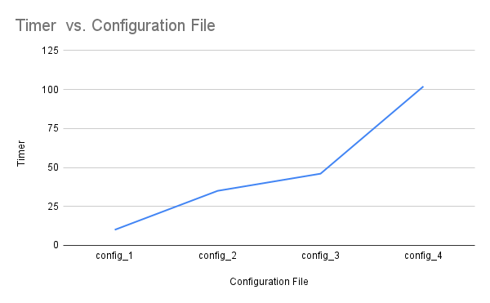

**NOTE:**

Due to some bugs in the Truck action method, when the configuration file is run the program does not end on its own and has to be closed. Thus the final timer value is not printed out. Everything else functions as expected. The above values were found by keeping track of the timer variable using the debugger tool, hence they may not be fully accurate